Monday:

Check ytd’s close percentile. (take ytd close at 15pm)

Trade every 10/15 min.

Put in low close: active daycover on feature.

Tuesday:

Opening cover – if ytd close low, keep covering every x minutes.

**Wed:**

中兴通讯: bot 15k delta, reason: overdrop, government subsidy.

Tencent: bot 40k delta. Reason: hold quality long term.

Erroneous day cover – wrong – no today price yet.

Thurs:

Need to improve

1. Day trader (trading on percentile)

Today problems

1. Too many manual trades -> this is NOT ACCEPTABLE.
2. Too many screen monitoring -> I hate following the market.

6.15

Use trim trader to cut delta after close

Use day cover trader to trade intraday

Percentiletrader to trade 2 day move

Matrader – trade directional move

Weekly review:

All:

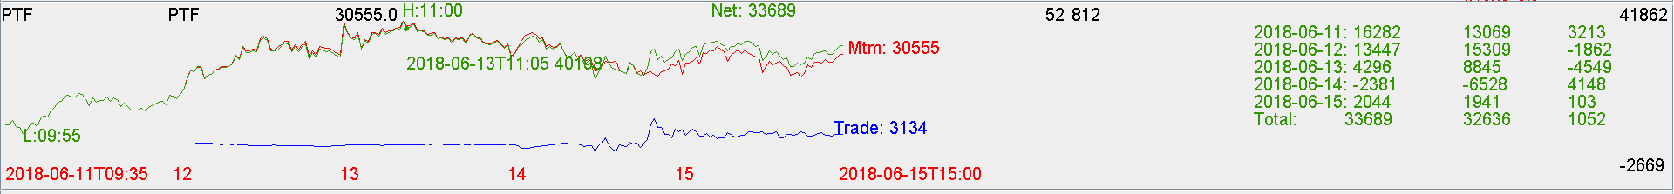

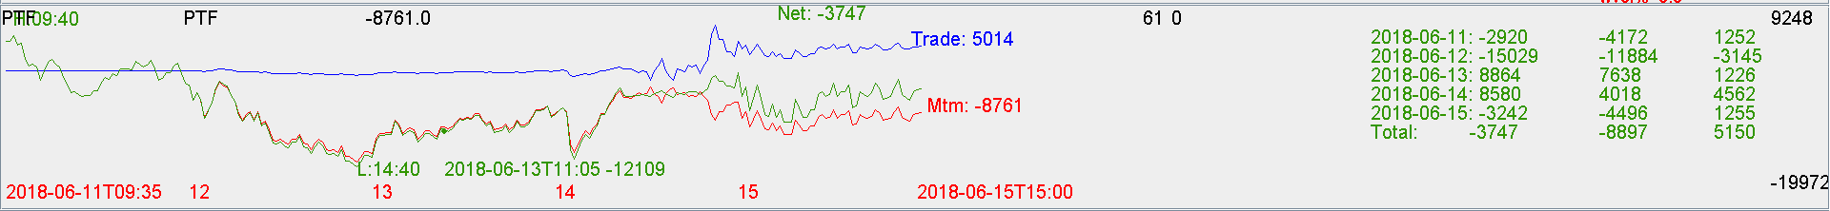

Fut:

Trade pnl positive, good.

Keep doing day trading based on percentile.

Stock:

Lost on the 2 HK stocks on 763 ZTE.

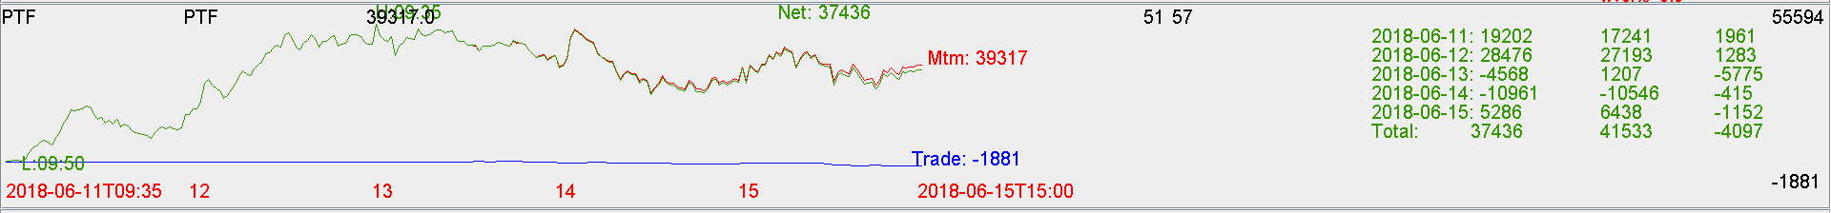

Big caps are very strong.

Roll trader: more spread out TWAP.

Day cover: more at the open dump, less later.